**Logic** is the use and study of valid reasoning (inductive, deductive, and abductive). In other words…it’s the study of how to make inferences (educated guesses) and reason out problems. Logic is used in most intellectual activities but studies primarily in the disciplines of Philosophy, Mathematics, Semantics, and Computer Science.

**The two main types of logic are:**

Informal Logic – study of language arguments

Mathematical Logic – formal logic and the study of inferences; symbolic logic and the study of abstractions.

In Mathematical Logic, the study of valid inferences is using formal language and symbols to derive a logical conclusion. An example would be a mathematical proof.

This section introduces symbolic logic by studying the truth value of statements (semantics). We will look to see if statements or arguments are true or false.

**I.** Statements, Compound statements, and Negation

A statement is _______________________________________________________________

___________________________________________________________________________

**EXAMPLE:** Determine if the following is a statement or not:

1. Some numbers are negative. ______________________________________________
2. Where are you going tomorrow? ___________________________________________
3. Yield to oncoming traffic. _________________________________________________
4. 5 + 9 ≠ 12 and 4 – 2 = 5 _________________________________________________

A compound statement is ______________________________________________________

___________________________________________________________________________

**EXAMPLE:** Determine if each statement is compound or not:

1. I read the Wall Street Journal and I read People Magazine. ______________________

______________________________________________________________________

1. My brother got married in France. __________________________________________
2. Jay’s wife loves Ben and Jerry’s ice cream. __________________________________

A negation of a true statement is _________________________________________________

A negation of a false statement is ________________________________________________

**EXAMPLE:** Write the negation of each statement:

1. Her sister’s name is Julie. ________________________________________________
2. The moon is a planet. ___________________________________________________
3. I drive a purple car. _____________________________________________________

Negation of mathematical inequalities: we use symbols in inequalities which represent opposite directions on a number line.

Less than

Less than or equal to

Greater than

Greater than or equal to

**EXAMPLE:** Write the negation of each inequality:

1. x < 9 ____________________ x ≥ -3 _____________________
2. 7x + 11y ≤ 77 ______________________________________________

**II.** Quantifiers

Quantifiers (quantity) are used to show “how many” cases of a situation exists.

Universal quantifiers: **all, each, every, no or none**

Existential quantifiers: **some, there exists, at least one**

When negating a statement that uses a quantifier, you need to think! Negating a quantity is not an all or nothing idea. It does not have to go from one extreme to the other.

all do…………some do not, not all do

some do …………none do, all do not

none do…………at least one does

**EXAMPLE:** Write the negation of each statement:

1. No rain fell in Arizona today. ______________________________________________
2. Some books are longer than this one. _______________________________________
3. No cats have fleas. _____________________________________________________

**EXAMPLE:** Refer to the group of flower pictures and frames. Each row is labeled A, B, C. Use the letters to identify which group of pictures is given by the statements below using quantifiers.

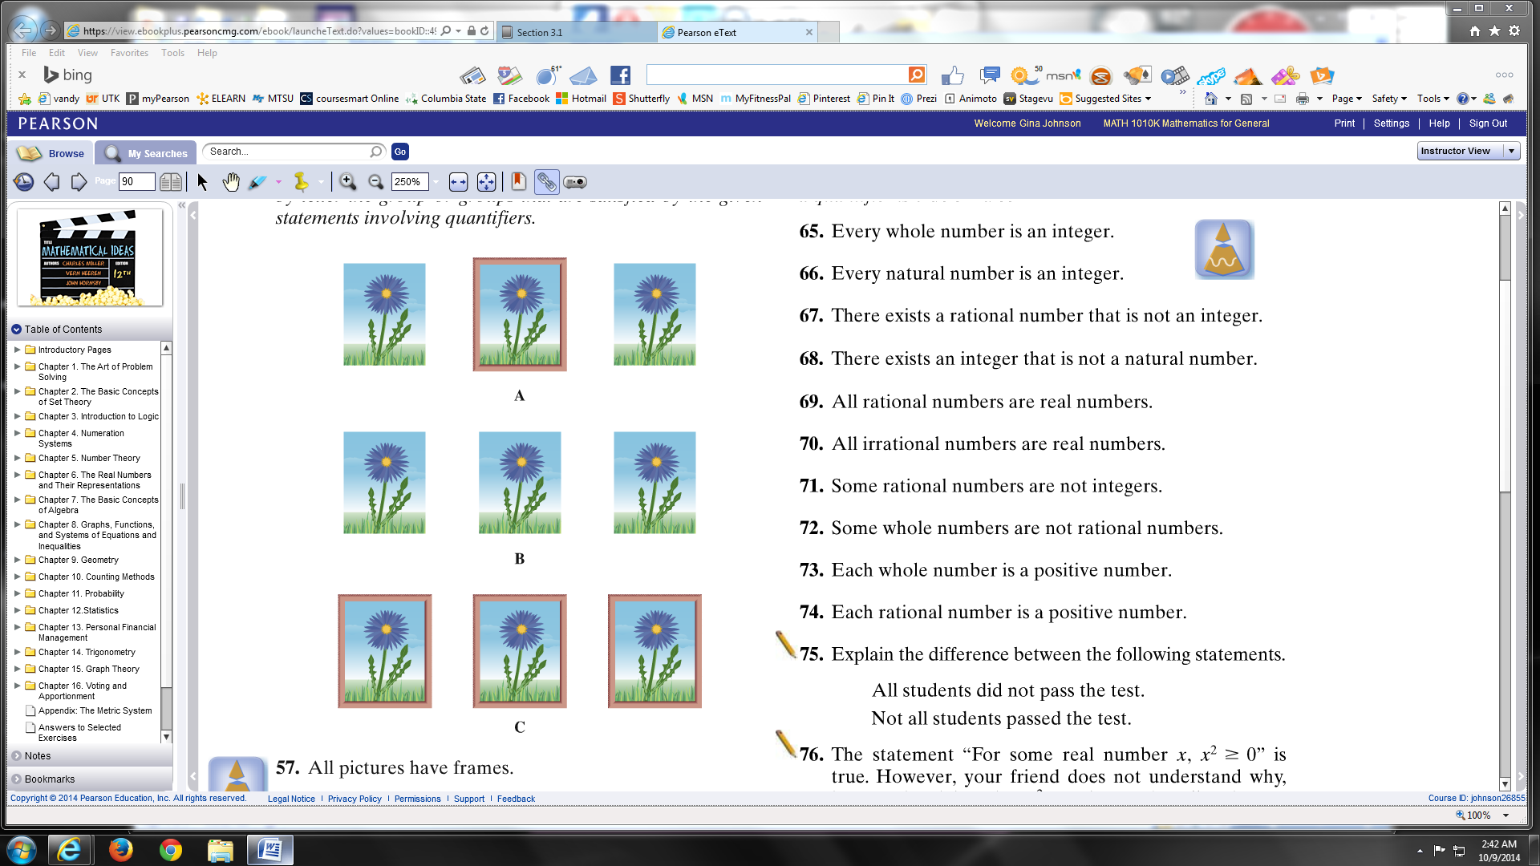

1. All pictures have frames. _______

2. No picture has a frame. _______

3. At least one picture does not

have a frame. ______ ______

4. Not every picture has a frame. ______ ______

5. At least one picture has a frame. ______ ______

6. All pictures do not have frames. _______

**III.** Logic Symbols

In logic, statements are represented by letters, such as ***p*** and ***q*** and ***r***.

In logic, connectives are represented by symbols:

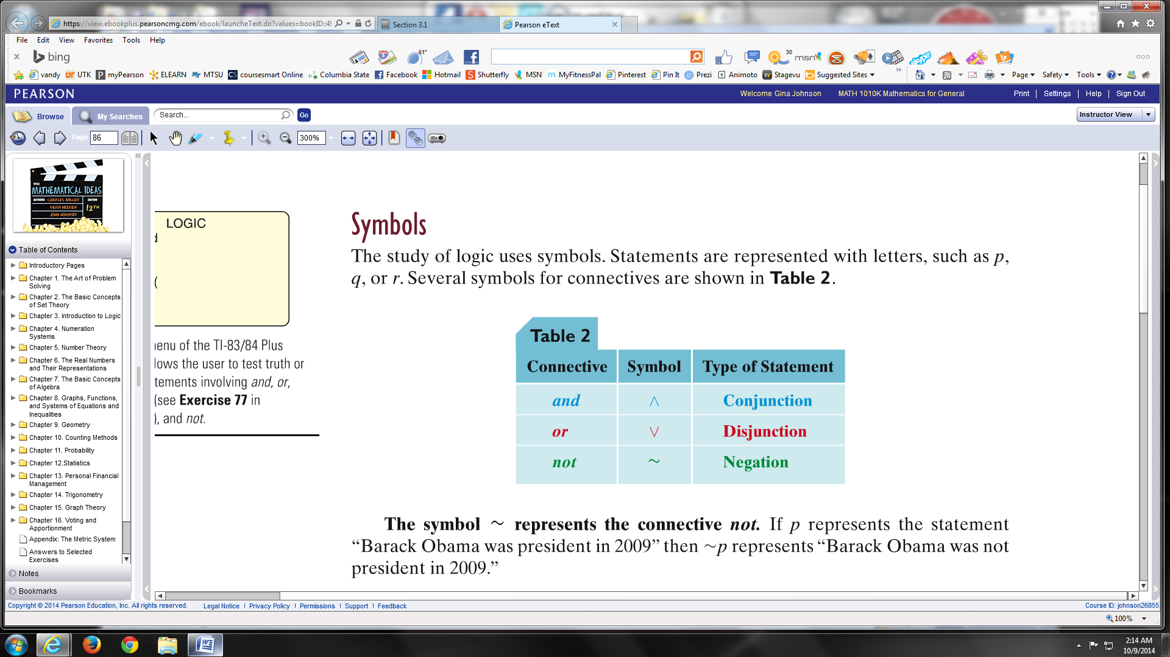

**EXAMPLE:** Translate the logic symbols to words:

p = Today is Sunday.

q = It is cold outside.

~p = ______________________________________________________________________

~q = ______________________________________________________________________

p ∨ q = ____________________________________________________________________

~p ∧ q = __________________________________________________________________

p ∨ ~q = __________________________________________________________________

p ∧ q = ____________________________________________________________________